Worksheet 1
Сайт Московского зоопарка: https://www.moscowzoo.ru.
Виртуальный тур по Московскому зоопарку: https://www.moscowzoo.ru/vtour/.
Аdditional information: https://clck.ru/Sqn3k и https://clck.ru/SqrXe.

- This is a map of the world. Mark the areas where the animals from the worksheet can be found in the wild.
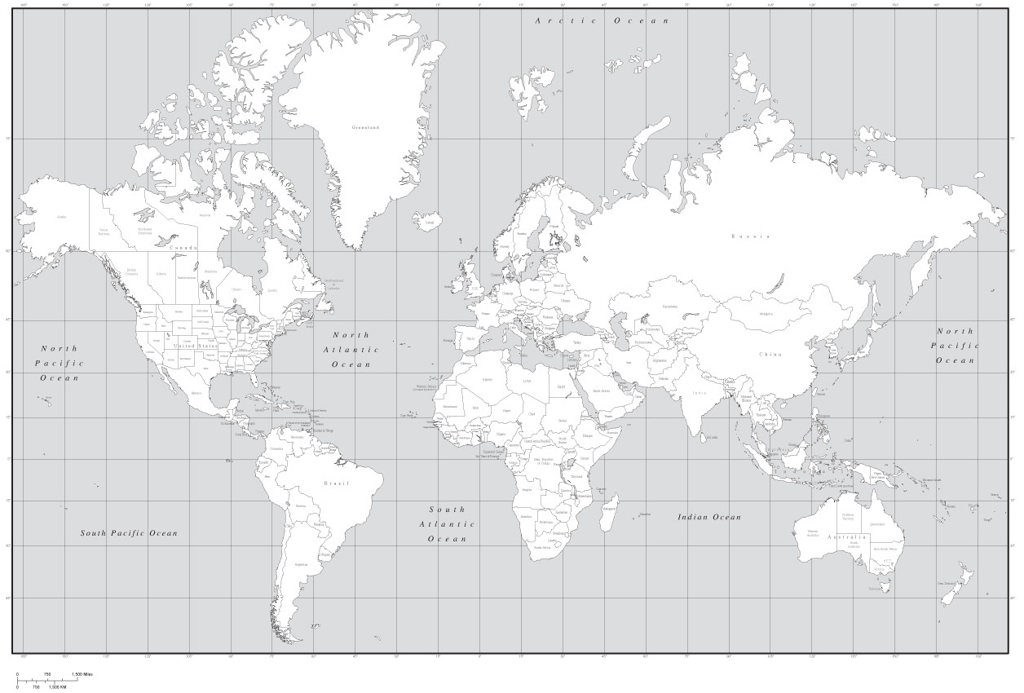
http://www.travelsworlds.com/wp-content/uploads/2014/03/world-map-black-and-whiteblack-white-world-map-with-countries-us-states-and-canadian-x3obqa0o.jpg
II. Birds of prey
- Match the words head, eye, beak/bill, wing, tail, talon, foot, breast with the parts of the body.
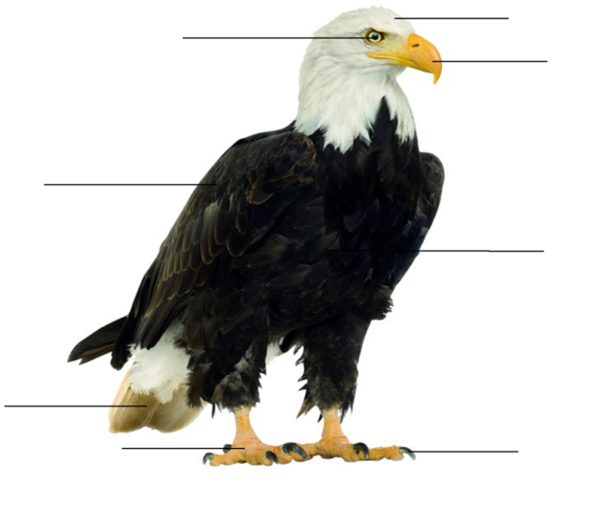
- What is a raptor? Choose the right variant:
- a bird that eats seeds and grains;
- a bird that catches and kills live animals for food.

- Which raptors can be found in the Moscow Zoo? Use additional information: https://clck.ru/Sqn3k и https://clck.ru/SqrXe.
________________________________________________________________________________________________________________________________________________________________________________________________________________________________________________________________________________
- What do they eat?
___________________________________________________________________
- How do they get their food in the wild?
___________________________________________________________________
- What special adaptations do these birds have to be good hunters?
___________________________________________________________________

- Fine two raptors. Fill in the table and compare two raptors using the Degrees of Comparison of Adjectives.
Name of the bird
Body size
Beak/bill
Body colour
Wings
Tail shape
Talons
Sounds
Diet
________________________________________________________________________________________________________________________________________________________________________________________________________________________________________________________________________________
- Capybaras
- Consider the pictures of the capybaras and complete the sentences
(Use additional information: https://clck.ru/Sqrjt).

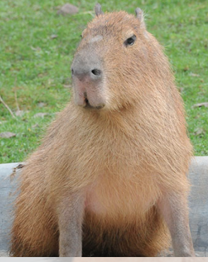 |  | 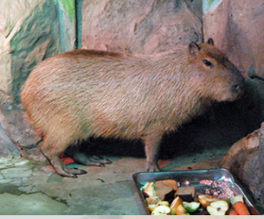 |  | 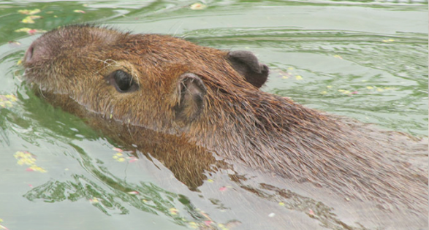

The capybara is the world’s largest ______________________________________.
The capybara eats ___________________________________________________.
The front legs are _____________________________________ than the hind legs.
The capybara has __________________________feet.
The head is ______________with the nostrils, eyes and ears are on the __________ of their head.
Capybaras have oily water-resistant fur, varying in color: ___________________.
Capybaras love rolling in the __________________________________________.
Capybaras love water and they are excellent ______________________________.
Capybaras come from ________________________________________________.
The animal’s predators are ____________________________________________.
- Which animals are the relatives of capybaras?
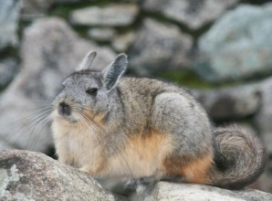 | 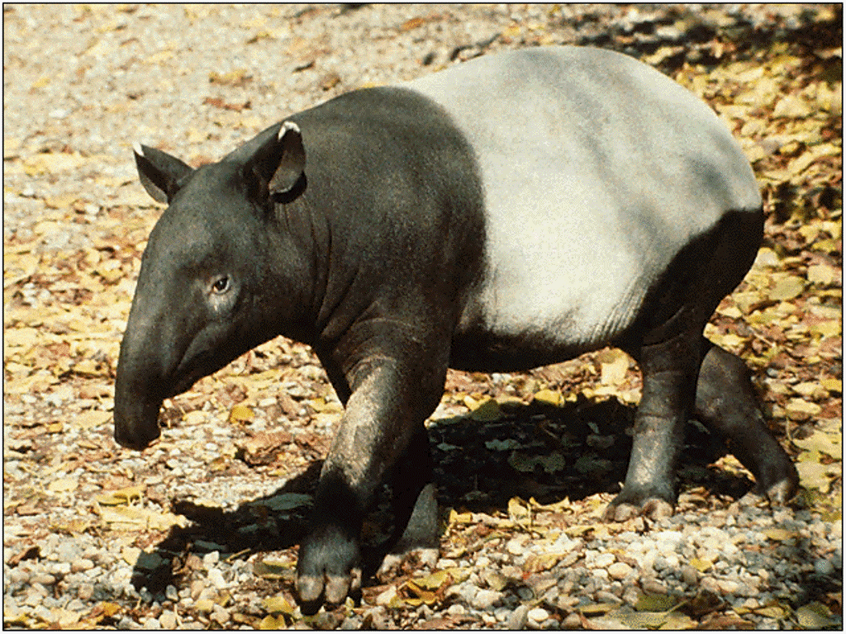 | 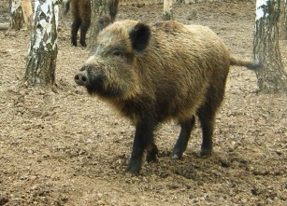 | 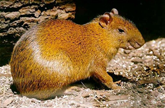
chinchilla [tʃɪnˈtʃɪlə] | tapir  [ˈteɪpə] | wild boar [ˌwaɪldˈbɔː] | agouti  [əˈɡʊttɪ]

- Spectacled bears
- Look at pictures of sloth bears (use additional information: https://clck.ru/SqtPS).

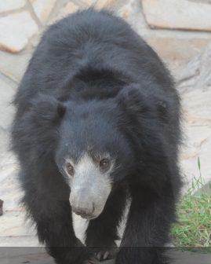 | 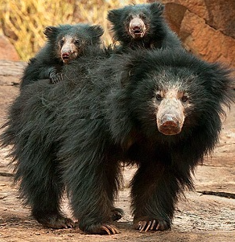 | 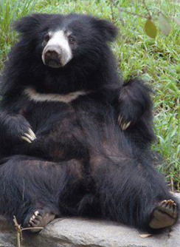

- Fill in the chart.
Scientific Name

Conservation Status
(common, threatened, endangered or extinct)

Body Length

Distribution
Habitat

Description

Diet

- Classify each animal as a consumer: herbivore [ˈhɜːbɪvɔː]( травоядное), carnivore [ˈkɑːnɪvɔː] (плотоядное животное ), omnivore [ˈɒmnɪvɔː] (всеядное животное)
herbivore | carnivore | omnivore

- Animal cinquain
Use the lines below to write a cinquain poem about an endangered animal.

Animal cinquain

_______________
(1 word — an animal)

_______________ _______________
(2 words that describe it)

_______________ _______________ _______________
(3 words expressing action)

_______________ _______________ _______________ _______________
(4 words telling what you feel about it)

_______________
(sum up with 1 word)

- Using the photos and the information from the worksheets make “Animal fact book”.

